Biology 0861 Worksheet on Viruses – Chapter 19-2: p.478-483
1. What is a virus?
________________________________________________________________
2. How do viruses reproduce?
________________________________________________________________
3. Identify this type of virus:
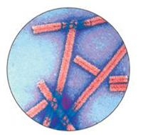
_______________________ _______________________
4. Complete the sentence: A ____________________ is the virus’s protein coat.
5. True or false? Because viruses must bind precisely to proteins on the cell surface and then use a host's genetic system, most viruses are not specific to the cells they infect. ________
6. In what type of infection (lytic or lysogenic) does the bacteriophage enters a cell, makes copies of itself, and causes the cell to burst? ___________________
7. In what type of infection (lytic or lysogenic) does the bacteriophage enters a cell and replicate with bacterium for many generations? ___________________
8. How is called the bacteriophage DNA inserted into a bacterial chromosome? ___________________

9. How are retroviruses different from other viruses?
________________________________________________________________
10. Viruses are at the borderline of living and non living things.
a) Give two characteristics of viruses that make them different from real living things.
1. _________________________________________________________
2. _________________________________________________________
b) Give three characteristics of viruses that make them similar from real living things.
1. _________________________________________________________
2. ________________________________________________________
3. _________________________________________________________

