Biology 0871 Worksheet on Reptiles – Chapter 31-1: p797-805

1. Give four characteristics that are common to reptiles but different from amphibians.
- ______________________________________
- ______________________________________
- _______________________________________
- ______________________________________

2. True are false? Reptiles are endotherms: Their temperature is controlled by picking up heat from or losing heat to their environment. ________________

3. Can reptiles exchange gases through their skin like amphibians? ________

4. True are false? Most reptiles have 2 lungs, but some snakes have one lung. _________

5. How many chambers form the heart of reptiles? _________

6. Complete the sentences on reptile excretion:
a) Reptiles that live mainly in water excrete their nitrogenous waste as _________________.
b) Terrestrial reptiles tend to convert _________________ into _________________
c) Which one need to be more diluted due to toxicity? _________________.

7. Identify the structures of the reptile that are involved in excretion.

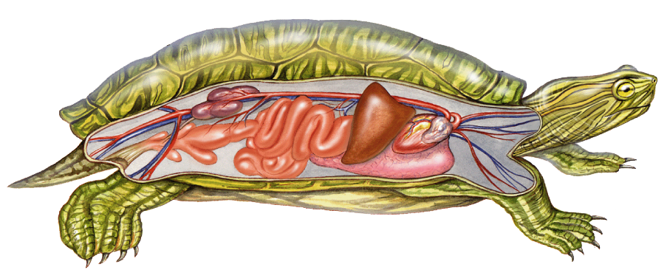

8. Which reptiles have a better view of colors : Reptiles active during the day or the ones active during the night? ____________________________________

9. What is the pair of sensory organs in the roof of the mouth for?
________________________________________________________________
10. Name the four membranes of an amniotic egg.
- _________________________
- _________________________
- _________________________
- _________________________

11. What group of animals living today are descendants of the dinosaurs?
________________________

12. Name the four surviving groups of reptiles and give one characteristic of each group.
- ______________________ ___________________________
- ______________________ ___________________________
- ______________________ ___________________________
- ______________________ ___________________________

13. How is called
a) the dorsal part of the turtles and tortoises? ____________________
b) the ventral part of the turtles and tortoises? ____________________

