Biology 0871 Worksheet on Mollusks
Chapter 27-4: p701-707
1. What larval stage do mollusks share with annelids?
______________________
2. Identify the structures to their definition:
a) Part of the mantle that is used for locomotion or attachment. ________
b) Contains most of the internal organs (digestive, excretory, circulatory, nervous systems). ________________
c) Aquatic mollusks breathe through _____________ while land mollusks breathe through _____________.
d) A soft, outer layer of mollusk bodies which generally produces a protective shell. _____________________
e) Snails and slugs feed using a flexible, tongue-shaped structure known as _______________, which possesses many teeth.

3. True or false?
a) Mollusks have a complete digestive track. ________
b) Mollusks have a closed circulatory system, except cephalopods which possess an opened circulatory system. ________
c) All mollusks are hermaphrodite. ________
d) All bivalves are sessile. ________
e) At least one representative in each class of mollusks possesses a radula. ________

4. Give the class in which the following organisms is part of:
a) oyster ______________________
b) squid ______________________
c) nudibranch ______________________
d) land slug ______________________
e) nautilus ______________________
f) limpet ______________________

5. Identify the pointed structures on the clam and give their roles.
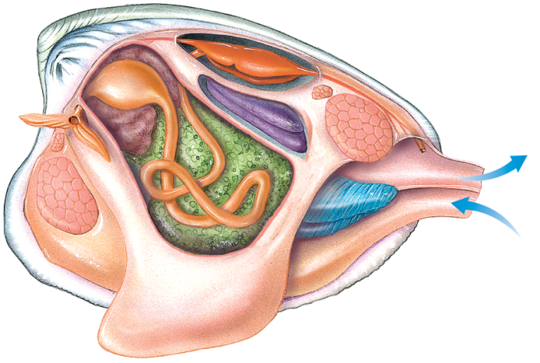
d
c
b
a
a) structure: _______________ role: __________________________________
b) structure: _______________ role: __________________________________
c) structure: _______________ role: __________________________________
d) structure: _______________ role: __________________________________

6. Which class includes the most intelligent invertebrates?
__________________________________

7. Give three uses of the siphon in cephalopods.
1. __________________________________
2. __________________________________
3. __________________________________

