Biology 0871 Worksheet on Mammals – Chapter 31-2: p806-814

1. What are the two notable features found in all mammals, at least at one stage of their life?
- _______________________________________________________
- _______________________________________________________
2. Like birds, mammals are endotherms; their bodies can generate heat internally. What else permits most mammals to keep the body warm? Give two characteristics.
________________________ ________________________
2. What permits most mammals to keep the body cool? ________________________

3. Name the four specialized types of teeth.
________________________ ________________________
________________________ ________________________

4. What is the rumen and what type of mammal has one?
________________________________________________________________________________________________________________________________________________________________________________________________

5. The lungs are controlled by two sets of muscles. Complete the sentences:
a) The contraction of the __________________________ expands the rib cage, increasing the volume of the chest cavity.
b) The contraction of the __________________________ pulls the chest cavity downward which further increases its volume.

6. a) The circulation system in mammals includes how many loops? ____
b) How many chambers constitute the heart of a mammal? ____
7. Which side of the heart receive the oxygen rich blood? __________________
8. Among the structures that are already pointed, identify the ones that are involved in:
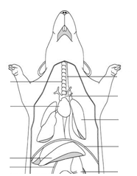
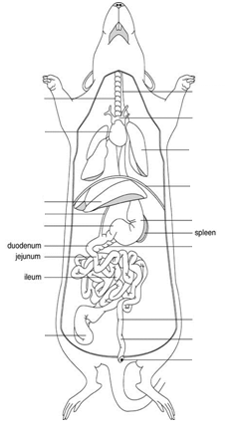
a) The digestive system b) The circulation and respiratory systems
c) The urinary system
a) b)

c)

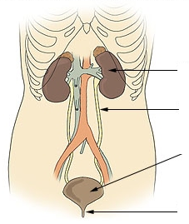

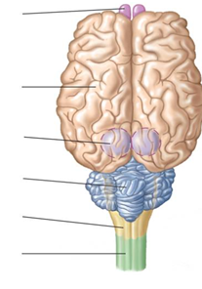
9. Identify the pointed structures of the human brain.

10. Is color vision most useful to animals that are active during the day or active during the night? ___________________

11. a) Associate with a line the group of living mammals to one of its representatives.
b) Indicate the characteristic(s) that make the groups different from each other.
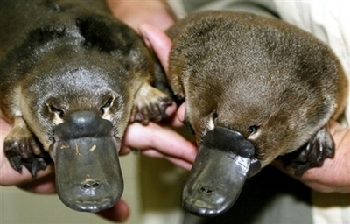
Placentals
1 characteristic:
__________________________________________________________________
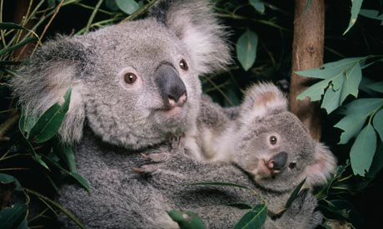
Marsupials
1 characteristic:
__________________________________________________________________

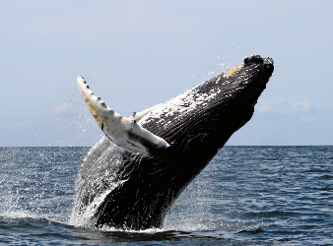
Monotremes
2 characteristics:
__________________________________________________________________
__________________________________________________________________

