Biology 0861 Exercise on Fungi – Chapter 21: p526 - 542

21-1 The Kingdom Fungi
1. Identify the structures.
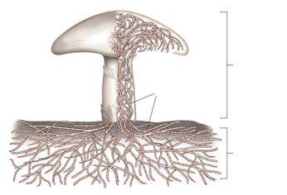
2. True or false?
______Fungi digest food outside of their bodies.
______Most fungi reproduce only asexually.
______Sexual reproduction involves two mating types: male and female.
______Fungi are non photosynthetic.

21-2 Classification of Fungi
3. Which phylum of fungi is the largest (most numerous species)?
________________________________
4. Penicillium notatum is a mold that grow on fruit and is the source of the antibiotic penicillin. Give its phylum: ______________________
5. The bracket fungi is a ____________________(give the phylum).

6. The following figure represents the life cycle of the black mold.
#1 represents the ______________ reproduction.
#2 represents the ______________ reproduction.
2
1

7. Identify the structures of the black mold.
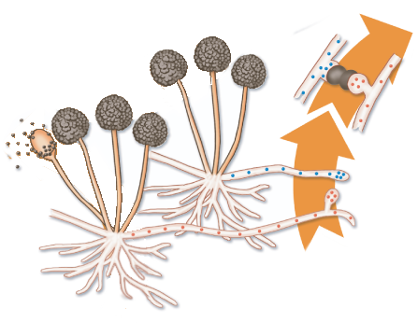

8. The following figure represents a section of the sexual reproduction of the ascomycetes. Identify the structures.
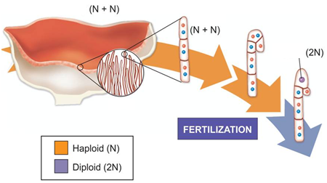
9. a) In the sexual reproduction of the ascomycetes, the spores are called _______________________.
b) In the asexual reproduction of the ascomycetes, the spores are called _______________________.
10. The following figure represents the life cycle of the basidiomycetes. Identify the structures.
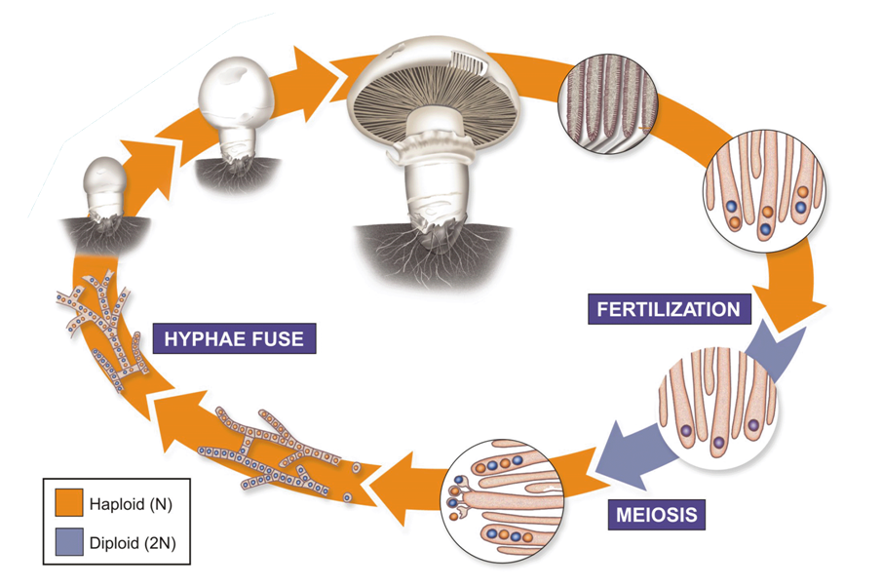
11. What do species of the phylum Deuteromycota have in common?
________________________________________________________________________________________________________________________________
21-3 Ecology of Fungi
12. Complete the sentence:
Lichen is the symbiosis between a fungi and _____________________or ________________________, or both.
13. Give four examples of diseases caused by fungi.
1)_________________________________
2)_________________________________
3)_________________________________
4)_________________________________
14. Give three examples of fungi uses by humans.
1)_________________________________
2)_________________________________
3)_________________________________
15. Why are decomposers, such as fungi, so important?
________________________________________________________________________________________________________________________________________________________________________________________________
16. What are mycorrhizae? How does the fungi benefit? How does the plant benefit?
________________________________________________________________________________________________________________________________________________________________________________________________

