**Biology 0861 Worksheet on Bacteria – Chapter 19-1: p471-477**

1. True or false?

a) Prokaryotes are unicellular organisms that lack a nucleus. _________

b) Archaebacteria is the larger of the two kingdoms of prokaryotes. _________

c) Archaebacteria genes are more like those of eukaryotes than those of eubacteria. _________

2. What is the different between cell walls of eubacteria and archaebacteria?

________________________________________________________________

3. Identify the pointed structures of *E. coli*, a typical Eubacteria found in human intestine.

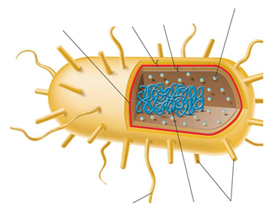

4. Eubacteria include organisms that live in a variety of environments. Give three examples.

1. ______________________________________________________
2. ______________________________________________________
3. ______________________________________________________

5. Many archaebacteria live in extreme environments. Give two examples of environments where they live.

1. ______________________________________________________
2. ______________________________________________________

6. Give the four characteristics that permit to identify prokaryotes.

1. ______________________________________________________
2. ______________________________________________________
3. ______________________________________________________
4. ______________________________________________________

7. By looking at their shape, identify these prokaryotes.

a) 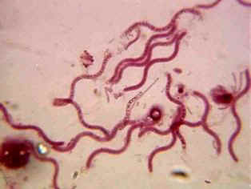 ___________ b) 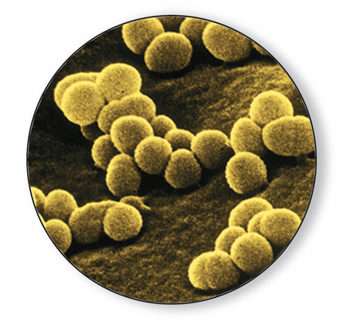 ___________

c) ___________

8. Define Gram-positive and Gram-negative bacteria.

Gram-positive : ________________________________________________________________

Gram negative : ________________________________________________________________

9. Complete the sentences:

a) ___________________________ require a constant supply of oxygen.

b)Bacteria that live without oxygen because they may be killed by it are called ___________________________.

c)Bacteria that can survive with or without oxygen are known as ___________________________.

10. Schematize the conjugation reproduction, and identify the hollow bridge.

11. Complete the sentences about bacteria lifestyles :

a) __________________________ capture energy by photosynthesis.

b) Many plants have symbiotic relationships with __________________________ bacteria in their roots.

c) Others are __________________________ that break down the nutrients in dead matter.