Biology 0871 Worksheet on Arthropods
Chapter 28-2
1. What are three important characteristics that arthropods have?
____________________ ____________________ ____________________
2. Complete the table.
Groups of arthropods
ex. of organisms
# of body segments
name of body segments
# of pair of antennae
# of pair of walking legs
feeding parts

3. How do terrestrial arthropods breath?
______________________________________________________________________________________________________________________
4. How do aquatic arthropods breath?
______________________________________________________________________________________________________________________
5. Complete the sentences:
a) Arthropods have a(n) __________(opened/closed) circulatory system.
b) Terrestrial arthropods dispose of nitrogenous wastes using _________________ which are sac like organs that extract wastes from the blood and then add them to the digestive waste.
c) Aquatic arthropods extract their wastes by ____________________.
6. Do arthropods have a brain? _______

7. a) What are compound eyes? ______________________________________
________________________________________________________________
b) Do mollusks have compound eyes? ______
8. To what are attach the muscles of the arthropods? ______________________
9. How do arthropods grow, knowing that their exoskeleton does not grow?
______________________________________________________________________________________________________________________
10. Identify the external anatomy of the crayfish.
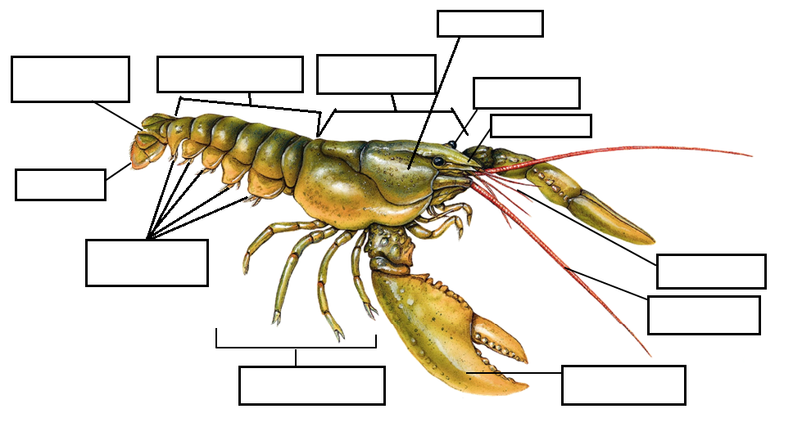
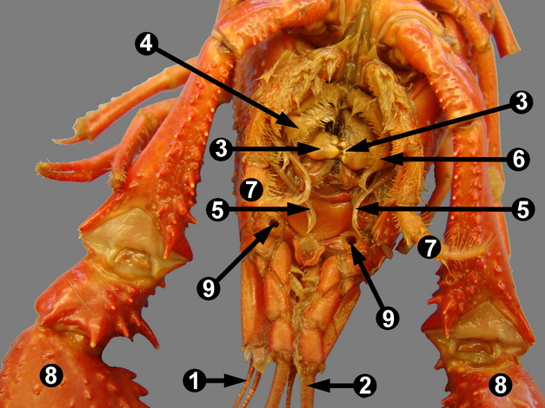
11. Identify the following numbers on the mouth parts of the crayfish.
1. _____________________
2. _____________________
3. _____________________
4. _____________________
5. _____________________
6. _____________________
7. _____________________
8. _____________________

