Biology 0871 Worksheet on Annelids
Chapter 27-3: p694-698
1. Give two characteristics of annelids that make them different from other worms.
_______________________________ ________________________________
2. Identify the scheme that represents the body of a coelomate, a pseudocoelomate, and an acoelomate, and identify which are roundworms, annelids and flatworms.
________________ ________________ ________________
________________ ________________ ________________

3. Complete the sentence: The body of an annelid is divided into segments.
Each segment is separated by ________________, which are internal walls between each segment.

4. True or false? Annelids have complex organ systems. __________

5. Identify the pointed structures of the annelid.

6. a) What is the clitellum?
______________________________________________________________________________________________________________________
b) Identify the clitellum on the image.
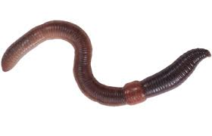
7. Identify the classes of annelids:
a) Live in soil and fresh water mainly : ______________________
b) External parasites that suck blood : ______________________
c) Some live in a protective tube they secrete : ______________________

