Biology 0871 Worksheet on Amphibians
Chapter 30-3: p782-789
1. What does “amphibian” mean? ________________________________________________________________
2. a) What is the respiratory organ in larval amphibian?____________________
b) What is the respiratory organ in adult amphibian?____________________
3. Point and identify on the scheme the organs that are involved in the digestion of the frog.
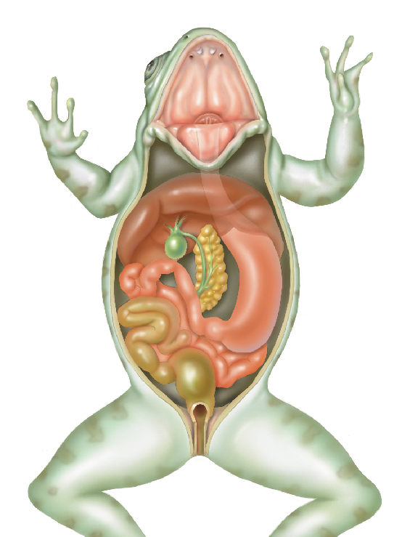
3. True or false?
a) Adult amphibians get oxygen from their lungs and their skin. _________
b) There is some mixing of oxygen-rich and oxygen-poor blood. ________

4. Draw a scheme of the amphibian heart. Identify the separated chambers and shows the circulation of the blood with arrows.

5. Point and identify on the scheme the organs that are involved in the excretion of the frog.
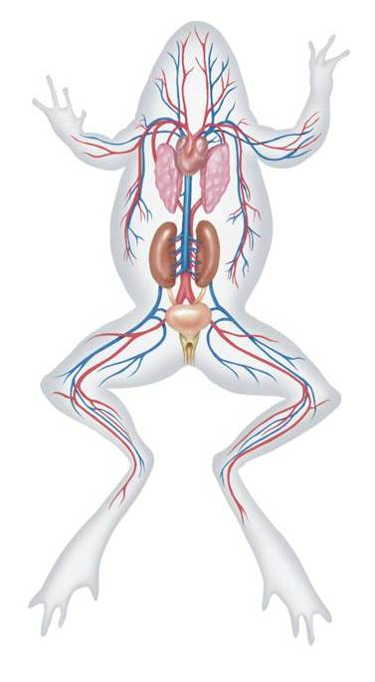
6. Complete the sentences about reproduction of amphibians:
Most amphibian eggs are fertilized by males ________________ (externally/internally) in ________________ (water/the female). However, salamanders eggs are fertilized ________________ (externally/internally).

7. True or false?
a) Eggs of amphibians are hard shelled. __________
b) Like fish, some amphibians possess a lateral line system, that detect water movement. __________

8. Complete the sentences:
a) The larval stage of amphibians is commonly called ________________.
b) Eyes of amphibians are protected by a transparent layer called __________________________.
c) Amphibians hear through ____________________, located on the side of the head.

9. Name the three groups of modern amphibians:
- _________________________________
- _________________________________
- _________________________________

10. Where do toads often live? _______________________________________

11. Give two adaptations that some amphibians have to protect them from predators.
- __________________________________________________________
- __________________________________________________________

12. Global amphibian population is declining due to decreasing habitat and changes in the environment. Give five susceptible threats to the populations of amphibians.
1. ___________________________________________________________
2. ___________________________________________________________
3. ___________________________________________________________
4. ___________________________________________________________
5. ___________________________________________________________

