Biology 0861 Worksheet on Plantlike Protists
Chapter 20-3, 20-4 and 20-5: p506-520
20-3 Plantlike Protists: Unicellular Algae
1. How do plantlike Protists differ from plants? Give five characteristics.
- Lack true roots
- Lack true leaves
- Lack true stems
- Some are unicellular
- Some are motile

2. Complete the table. Name the four phyla of plantlike protists that are unicellular algae. Give a few characteristics, an information about their nutrition, and their means of reproduction.
Phyla: | Euglenophytes | Chrysophytes | Diatoms | Dinoflagellates
Few characteristics: | 2 flagella  gullet, pellicle, eyespot, carbohydrate storage bodies, contractile vacuole | Gold-colored chloroplasts | Two petri shaped like cells,  cell wall in silicon | 2 flagella  2 plates of cellulose  luminescence
Nutrition: | photosynthesis or saprophytic | Store food as oil |  | photosynthtic or heterotroph
Reproduction: | binary fission | Asexually  Sexually |  | binary fission

3. In Euglena, what is the function of the eyespot?
It helps the organism find sunlight to power photosynthesis.

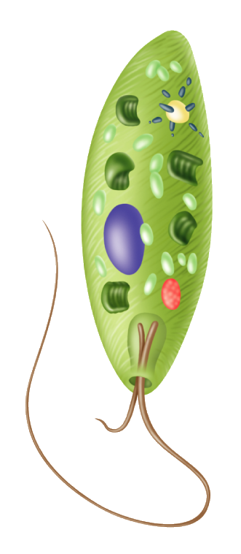
4. Identify the structures of an euglena.
nucleus chloroplast
gullet

carbohydrate storage bodies
flagella
contractile vacuole
eyespot

5. a) What is phytoplankton? It constitute the population of small, photosynthetic organisms found near the surface of the ocean.
b) Give two reasons why phytoplankton is important in ecosystems.
- Phytoplankton carry out half of Earth’s photosynthesis.
- They provide nourishment for many organisms.

6. What is an algal bloom? Are they good, bad? Why?
When the amount of waste is excessive, populations of algae may grow into enormous masses called algal blooms. Algal blooms are bad. They deplete the water of nutrients, and the cells die in great numbers. The decomposition of these dead algae can rob water of its oxygen, choking its resident fish and invertebrate life.

7. What is red tide and why is eating shellfish from areas infected with red tide dangerous?
Some species of algae release toxins, such as Gonyaulax and Karenia. They cause “red tides”. Filter-feeding shellfish such as clams can trap them for food and become filled with the toxin. Eating shellfish from water infected can cause serious illness, paralysis, and even death in humans and fish.

20-4 Plantlike Protists: Red, Brown, and Green Algae
8. How are most of the red, brown and green algae similar to the plants? Give four characteristics.
- Most of these algae are multicellular
- Their reproductive cycles are sometimes very similar
- Many have cell walls
- Same photosynthetic pigments
- Many have specialized tissues

9. The most important difference among these phyla involved their photosynthetic pigments. For each phyla, name their pigments.
Red algae: Chlorophyll a and phycobilins
Brown algae: Chlorophyll a, chlorophyll b and fucoxanthin
Green algae: Chlorophyll a, chlorophyll b

10. What alga phylum would be the ancestor of land plants?
Green algae
11. a) Identify the structure of the brown.

b) What is the function of the holdfast?
The holdfast attaches the alga to rocks
c) What is the function of the bladders?
The bladders are gas-filled and keep the alga afloat and upright.
12. Why is Volvox considered half way between a colony and a multicellular organism?
Volvox exhibits some cell specialization (characteristic of multicellular life), but most of cells are identical (characteristic of colonial life).

13. In the asexual reproduction of the unicellular green algae Chlamydomonas, how are called the cells produced by mitosis? Zoospores

14. When conditions are unfavorable, Chlamydomonas reproduce sexually. Give two reasons why this is a good adaptation.
- Two cells pair their gametes (give new genes, new chances to survive in a tough environment)
- The zygote grows a thick protective wall. Within this protective wall, Chlamydomonas can survive conditions that otherwise would kill it.
15. Identify the structures of the reproduction cycle of Ulva and identify the ploidy of each structure.
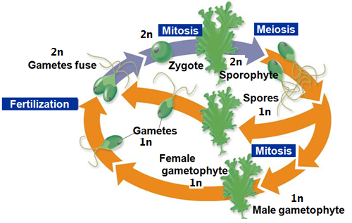
20-5 Funguslike Protists
16. a) Give two similarities between funguslike protists and fungi.
- Absorb nutrients from dead or decaying organic
- They do not do photosynthesis
b) Give two differences between funguslike protists and fungi.
- Funguslike protists contain centrioles
- Funguslike protists lack the chitin cell walls of true fungi
17. Draw the life cycle of the acellular slime mold and identify the structures that are involved.
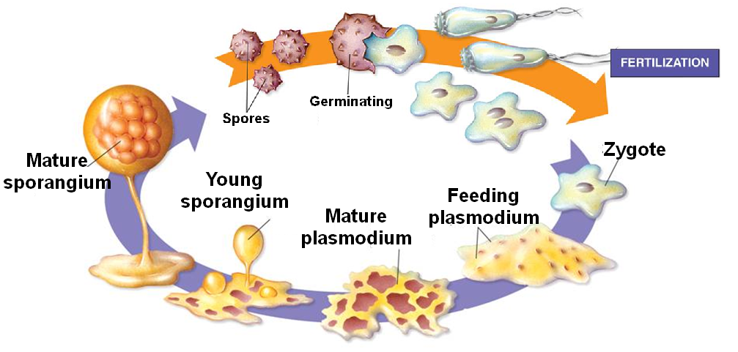
18. Draw the life cycle of the water mold and identify the structures that are involved.
