Biology 0861 Worksheet on Plantlike Protists
Chapter 20-3, 20-4 and 20-5: p506-520
20-3 Plantlike Protists: Unicellular Algae
1. How do plantlike Protists differ from plants? Give five characteristics.
- _________________________________________
- _________________________________________
- _________________________________________
- _________________________________________
- _________________________________________

2. Complete the table. Name the four phyla of plantlike protists that are unicellular algae. Give a few characteristics, an information about their nutrition, and their means of reproduction.
Phyla:
Few characteristics:

Nutrition:

Reproduction:

3. In Euglena, what is the function of the eyespot?
________________________________________________________________

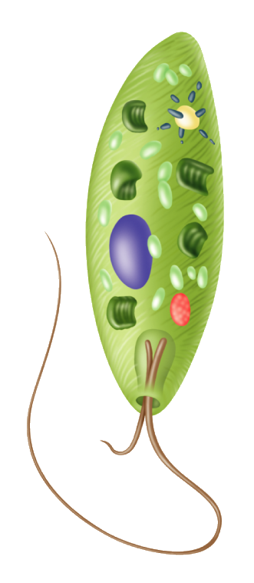
4. Identify the structures of an euglena.

5. a) What is phytoplankton?
________________________________________________________________________________________________________________________________
b) Give two reasons why phytoplankton is important in ecosystems.
- ____________________________________________________________________________________________________________
- ____________________________________________________________________________________________________________
6. What is an algal bloom? Are they good, bad? Why?
________________________________________________________________________________________________________________________________________________________________________________________________________________________________________________________________________________________________________________________________________________________________________________________________
7. What is red tide and why is eating shellfish from areas infected with red tide dangerous?
________________________________________________________________________________________________________________________________________________________________________________________________________________________________________________________________
20-4 Plantlike Protists: Red, Brown, and Green Algae
8. How are most of the red, brown and green algae similar to the plants? Give four characteristics.
- ___________________________________________________________
- ___________________________________________________________
- ___________________________________________________________
- ___________________________________________________________
9. The most important difference among these phyla involved their photosynthetic pigments. For each phyla, name their pigments.
Red algae: ________________________________________________
Brown algae: ________________________________________________
Green algae: ________________________________________________

10. What alga phylum would be the ancestor of land plants?
________________________________________________

11. a) Identify the structure of the brown.

b) What is the function of the holdfast?
________________________________________________________________
c) What is the function of the bladders?
________________________________________________________________
12. Why is Volvox considered half way between a colony and a multicellular organism?
________________________________________________________________
________________________________________________________________

13. In the asexual reproduction of the unicellular green algae Chlamydomonas, how are called the cells produced by mitosis? ____________________________
14. When conditions are unfavorable, Chlamydomonas reproduce sexually. Give two reasons why this is a good adaptation.
- ____________________________________________________________________________________________________________
- ____________________________________________________________________________________________________________
15. Identify the structures of the reproduction cycle of Ulva and identify the ploidy (n, 2n) of each structure.
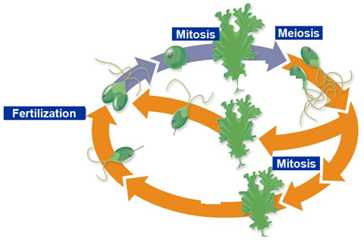

20-5 Funguslike Protists
16. a) Give two similarities between funguslike protists and fungi.
- ___________________________________________________________
- ___________________________________________________________
b) Give two differences between funguslike protists and fungi.
- ___________________________________________________________
- ___________________________________________________________
17. Draw the life cycle of the acellular slime mold and identify the structures that are involved.

18. Draw the life cycle of the water mold and identify the structures that are involved.

