Biology 0871 Worksheet on Reptiles – Chapter 31-1: p797-805

1. Give four characteristics that are common to reptiles but different from amphibians.
- Dry, waterproof, scaly, tough skin
- Terrestrial eggs with several membranes (amniotic eggs)
- Can live their entire life outside water
- Sensory organ in mouth
- No gills at juvenile stage
- 4 chambered heart (some reptiles)
- No oxygen exchange through skin
- Others...

2. True are false? Reptiles are endotherms: Their temperature is controlled by picking up heat from or losing heat to their environment. ___False (they are ectotherms. description is correct)___

3. Can reptiles exchange gases through their skin like amphibians? __no__

4. True are false? Most reptiles have 2 lungs, but some snakes have one lung. _True_

5. How many chambers form the heart of reptiles? __3 or 4__

6. Complete the sentences on reptile excretion:
a) Reptiles that live mainly in water excrete their nitrogenous waste as __ammonia___.
b) Terrestrial reptiles tend to convert __ammonia__ into __uric acid__.
c) Which one need to be more diluted due to toxicity? _ammonia____.

7. Identify the structures of the reptile that are involved in excretion. 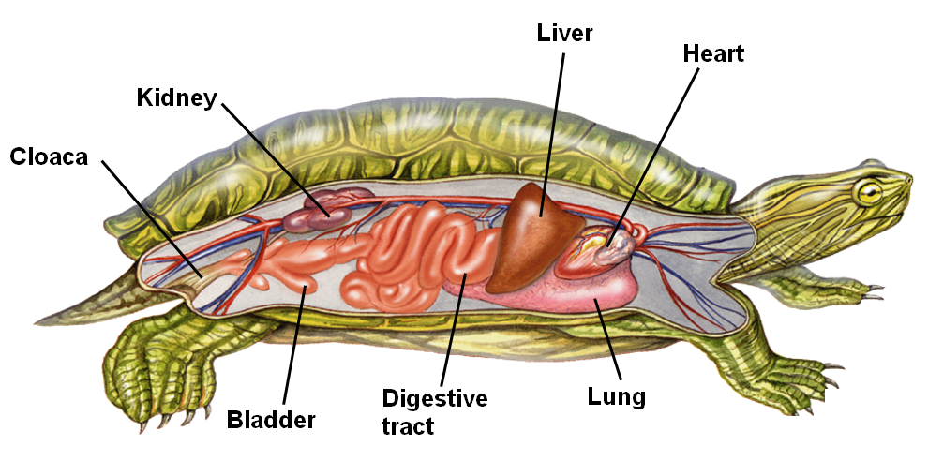
8. Which reptiles have a better view of colors : Reptiles active during the day or the ones active during the night? ______Active during the day________

9. What is the pair of sensory organs in the roof of the mouth for?
It can detect chemicals when the reptiles flick their tongues.

10. Name the four membranes of an amniotic egg.
- Amnion
- Chorion
- Yolk sac
- Allantois

11. What group of animals living today are descendants of the dinosaurs?
_______Birds_____

12. Name the four surviving groups of reptiles and give one characteristic of each group.
- Lizards and snakes (ex. lizards: clawed toes, snakes: no legs)
- Crocodilians (ex. long, broad snouts)
- Turtles and tortoises (ex. carapace and plastron)
- Tuatara (ex. “third eye”)

13. How is called
a) the dorsal part of the turtles and tortoises? ___carapace__
b) the ventral part of the turtles and tortoises? ___plastron__

