Biology 0871 Worksheet on Fish
Chapter 30-2 p771, 774-781
1. Name five feeding modes of the fish.
- _____________________
- _____________________
- _____________________
- _____________________
- _____________________

2. What organs are involved in fish’s digestion?
________________________________________________________________________________________________________________________________

3. Complete the sentence about respiration:
Most fishes exchange gases using ______________ located on either side of the pharynx. These are covered by a bony structure called the _______________.

4. Fish possess a closed circulatory system. How many loop(s) form their circulatory system? ____________.

5. Identify the four parts of the fish heart:

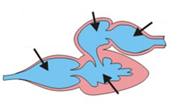
6. What organ filter wastes from the blood in fish?____________________.

7. Identify the structures of the well developed nervous system of the fish.
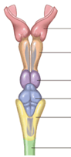

8. Fishes possess a sensory receptors on the side of their body and use it to detect other fishes swimming nearby. How is that structure called?
___________________________

9. What structure do most bony fish have to control their buoyancy? Where is it positioned in the fish body?
______________________________________________________________

10. Fishes whose eggs hatch outside the mother’s body are called _________________. Fishes whose eggs stay in the mother’s body after internal fertilization are called _________________. Fish whose embryo obtains nourishment not from the yolk but from the mother’s body are called _________________.

11. Give the phylum for each fish illustrated.
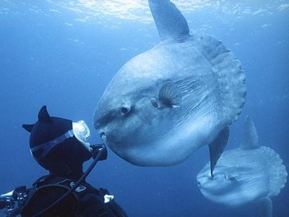______________________________
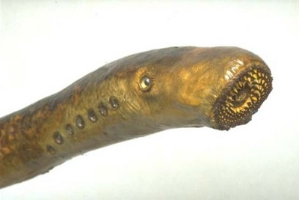______________________________
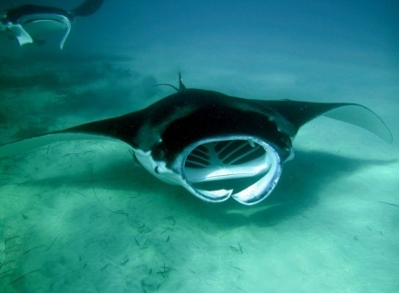______________________________
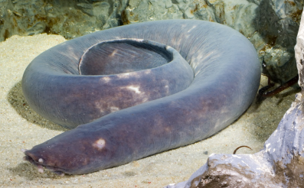______________________________

12. How are called the fish that live most their lives in salt water and migrate to the fresh water to breed? __________________________
13. Identify all the structures of the fish using figures 30-6 and 30-11.

