Biology 0871 Worksheet on Nonvertebrate Chordates
Chapter 30-1 p767-770

The two groups of nonvertebrate chordates are tunicates and lancelets.
- Feeding
1. What type of feeding tunicates and lancelets use? ___filter feeding_________
- Respiration
2. True or false? Lancelets exchange gases through their body surface. True
- Circulation
3. Do lancelets have a open or closed circulatory system? __closed______
4. Do lancelets have a true heart? ___no___
- Response
5. Do tunicates and lancelets have a well developed nervous system? ___no___
- Movement
6. Tunicates and lancelets don’t have fins or legs. How do the lancelets move?
____________By contracting the paired muscles on their bodies._________
- Reproduction
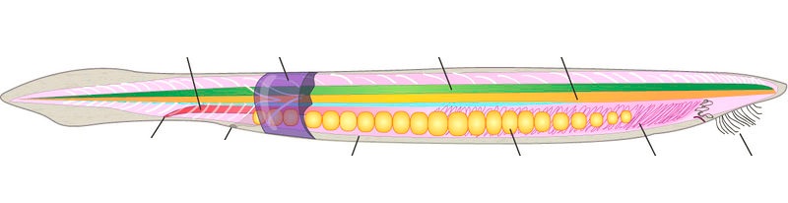
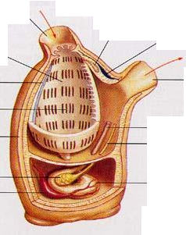
7. Point at the reproductive organs of the two nonvertebrate chordates.

