Biology 0861 Worksheet 1 on Protists – Chapter 20 1-2: p496 – 505

20-1 The Kingdom Protista
1. “Protista” means “the very first”. Protists are the firsts what?
____________________________________________________________
2. Mitochondria and chloroplasts may be descended from what?
________________________________________________________________________________________________________________________________
3. One way protists are classified is by how they obtain nutrition. For each groups, indicate their mean to obtain nutrition:
- Animal-like protists: _____________________________________
- Plantlike protists: _____________________________________
- Funguslike protists: _____________________________________
20-2 Animal-like Protists: Protozoans
4. Complete the table. Name the four phyla of animal-like protists, give their means of movement, feeding, reproduction, environments where they live and give an example of a species (or group) for each phylum.
Phyla:
Movement:
Feeding:
Reproduction:
Environment

Species ex.
5. Identify the pointed structures of the paramecium.
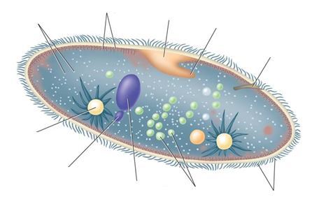
6. Complete the sentences:
Plasmodium is a protist from the phylum of _____________________ and causes the disease of _____________________. The mosquito that carries Plasmodium is called _____________________.

7. Indicate the cell stages of Plasmodium across its life cycle in its two hosts.
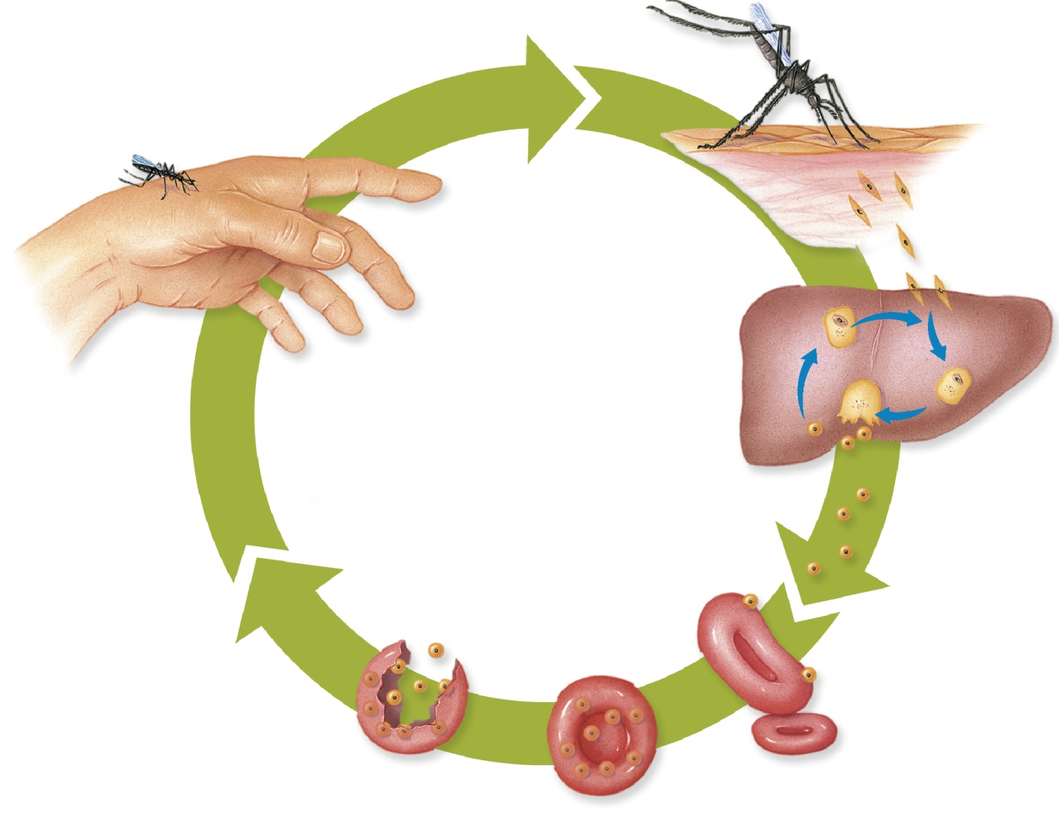
gametes cells in mosquito

